Bioinformatics for personalized medicine
By Carolina Barra Quaglia

Variant not found - GLP-1 R

What happens when you don't find your variant of interest?

As an example, we are going to work with a variant in glucagon-like peptide-1 receptor to assess whether patients bearing that mutation can respond to Ozempic

This is our sequence:

>Human glucagon-like peptide-1 receptor mRNA (Patient X)
TTCCGCAGGTGGCAGCGATGGCCCAGTCCTGAACTCCCCGCCATGGCCGGCGCCCCCGGCCCGCTGCGCC
TTGCCGTGCTGCTGCTCGGGATGGTGGGCAGGGCCGGCCCCCGCCCCCAGGGTGCCACTGTGTCCCTCTG
GGAGACGGTGCAGAAATGGCGAGAATACCGACGCCAGTGCCAGCGCTCCCTGACTGAGGATCCACCTCCT
GCCACAGACTTGTTCTGCAACCGGACCTTCGATGAATACGCCTGCTGGCCAGATGGGGAGCCAGGCTCGT
TCGTGAATGTCAGCTGCCCCTGGTACCTGCCCTGGGCCAGCAGTGTGCCGCAGGGCCACGTGTACCGGTT
CTGCACAGCTGAAGGCCTCTGGCTGCAGAAGGACAACTCCAGCCTGCCCTGGAGGGACTTGTCGGAGTGC
GAGGAGTCCAAGCGAGGGGAGAGAAGCTGGGGGGAGGAGCAGCTCCTGTTCCTCTACATCATCTACACGG
TGGCGTACGCACTCTCCTTCTCTGCTCTGGTTATCGCCTCTGCGATCCTCCTCGGCTTCAGACACCTGCA
CTGCACCAGGAACTACATCCACCTGAACCTGTTTGCATCCTTCATCCTGCGAGCATTGTCCGTCTTCATC
AAGGACGCAGCCCTGAAGTGGATGTATAGCACAGCCGCCCAGCAGCACCAGTGGGATGGGCTCCTCTCCT
ACCAGGACTCTCTGAGCTGCCGCCTGGTGTTTCTGCTCATGCAGTACTGTGTGGCGGCCAATTACTACTG
GCTCTTGGTGGAGGGCGTGTACCTGTACACACTGCTGGCCTTCTCGGTCTTCTCTGAGCAATGGATCTTC
AGGCTCTACGTGAGCATAGGCTGGGGTGTTCCCCTGCTGTTTGTTGTCCCCTGGGGCATTGTCAAGATCC
TCTATGAGGACGAGGGCTGCTGGACCAGGAACTCCAACATGAACTACTGGCTCATTATCCGGCTGCCCAT
TCTCTTTGCCATTGGGGTGAACTTCCTCATCTTTGTTCGGGTCATCTGCATCGTGGTATCCAAACTGAAG
GCCAATCTCATGTGCAAGACAGACATCAAATGCAGACTTGCCAAGTCCACGCGGACACTCATCCCCCTGC
TGGGGACTCATGAGGTCATCTTTGCCTTTGTGATGGACGAGCACGCCCGGGGGACCCTGCGCTTCATCAA
GCTGTTTACAGAGCTCTCCTTCACCTCCTTCCAGGGGCTGATGGTGGCCATCTTATACTGCTTTGTCAAC
AATGAGGTCCAGCTGGAATTTCGGAAGAGCTGGGAGCGCTGGCGGCTTGAGCACTTGCACATCCAGAGGG
ACAGCAGCATGAAGCCCCTCAAGTGTCCCACCAGCAGCCTGAGCAGTGGAGCCACGGCGGGCAGCAGCAT
GTACACAGCCACTTGCCAGGCCTCCTGCAGCTGAGACTCCAGCGCCTGCCCTCCCTGGGGTCCTTGCTGC
AGGCCGGGTGGCAATCCAGGTGGGAGAGACACTCCCAGGGACAAGGGAAGGAAGGGACACACACACACAC
ACACACACACACACACACACACATACATCCTGCTTTCCCTCCCCAAACCCATCAGACAGGTAAATGGGCA
GTGCCTCCTGGGACCATGGACACATTTTCTCCTAGGAGAAGCAGCCTCCTAATTTGATCACAGTGGCGAG
AGGAGAGGAAAAACGATCGCTGTGAAAATGAGGAGGATTGCTTCTTGTGAAACCACAGGCCCTTGGGGTT
CCCCCAGACAGAGCCGCAAATCAACCCCAGACTCAAACTCAAGGTCAACGGCTTATTAGTGAAACTGGGG
CTTGCAAGAGGAGGTGGTTCTGAAAGTGGCTCTTCTAACCTCAGCCAAACACAGAGCGGGAGTGACGGGA
GCCTCCTCTGCTTGCATCACTTGGGGTCACCACCCTCCCCTGTCTTCTCTCAAAGGGAAGCTGTTTGTGT
GTCTGGGTTGCTTATTTCCCTCATCTTGCCCCCTCATCTCACTGCCCAGTTTCTTTTTGAGGGCTTGTTG
GCCACTGCCAGCAGCTGTTTCTGGAAATGGCTGTAGGTGGTGTTGAGAAAGAATGAGCATTGAGACACGG
TGCTCGCTTCTCCTCCAGGTATTTGAGTTGTTTTGGTGCCTGCCTCTGCCATGCCCAGAGAATCAGGGCA
GGCTTGCCACCGGGGAACCCAGCCCTGGGGTATGAGCTGCCAAGTCTATTTTAAAGACGCTCAAGAATCC
TCTGGGGTTCATCTAGGGACACGTTAGGAATGTCCAGACTGTGGGTGTAGGTTACCTGCCACTTCCAGGA
CGCAGAGGGCCAAGAGAGACATTGCCTCCACCTCTCCTGAATACTTATCTGTGACCACACGCTGTCTCTT
GAGATTTGGATACACTCTCTAGCTTTAGGGGACCATGAAGAGACTCTCTTAGGAAACCAATAGTCCCCAT
CAGCACCATGGAGGCAGGCTCCCCCTGCCTTTGAAATTCCCCCACTTGGGAGCTGATATACTTCACTCAC
TTTTCTTTATTGCTGTGATAGTCTGTGTGCACAATGGGCAATTCTGACTTCTCCCATCTAGTGGAAATGA
GCGAAATCATGGTTGTAGTGATCTTG

NC_000006.12:39079580:T:G

- Where is the position of the variant and what is the change compared to the reference genome?
NC_000006.12:39079580:T:G

- Is the mutation translated into a change in the protein product?
Yes, there is a substitution of L for R

- Is the mutation known?
No

- Can we predict the effects of the mutation? Consider the following points:
  - Is the change in the amino acid a disruptive change?
L > R 354 Blosum score -2
  - Is the mutation located in a particular protein domain?
In an alpha helix number 6
  - Is the mutation in the transmembrane region? or in the GLP-1 binding region?
It is in one of the transmembrane regions, and probably will affect the membrane structure
  - Will the mutation prevent the interaction with agonist peptides?
No
  - Will the mutation affect the interaction with other relevant proteins?
No
  - Do you expect that the mutation will generate a different protein structure?
No, but it might affect the transmembrane portion see PyMOL figure
- Based on the above analysis. Do we expect that Ozempic will bind to GLP-1 R in this patient?

We expect that Ozempic will bind, but the mutation might alter the receptor function. We will have to try in the lab but it is likely that this mutation will not prevent binding

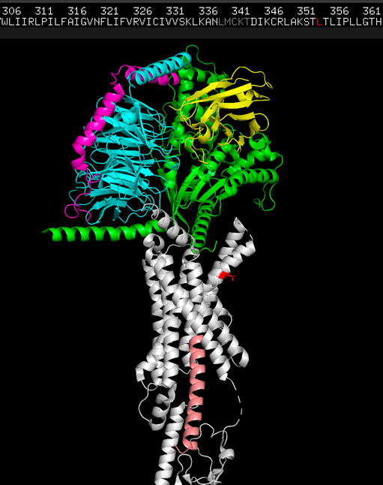
fetch 6X18

