Supplementary materials

Application of rapid Nanopore metagenomic cell-free DNA sequencing to diagnose bloodstream infections: a prospective observational study

Nielsen et al.

Table of contents
Supplementary Figures 3
Figure S1. Clinical characteristics of patients who were analyzed and excluded. 3
Supplementary Tables 4
Table S1. Detailed metadata on clinical presentation and antibiotics for all patients. 4
Table S2. Read depth and plasma cfDNA concentration for all patients and blood donors. 7
Table S3. Detailed metadata on the assessment of relevance of mNGS findings. 9
References 11

Supplementary Figures
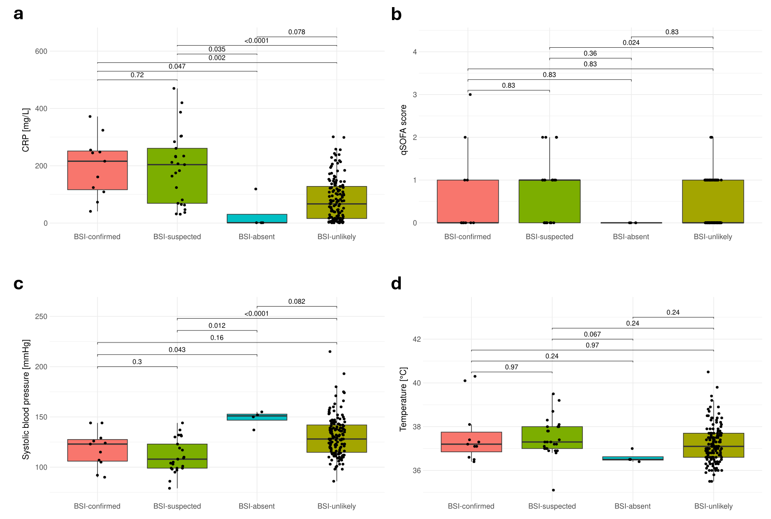

Figure S1. Clinical characteristics of patients who were analyzed and excluded.
a) CRP at blood culture for BSI-confirmed, BSI-suspected, BSI-absent, and BSI-unlikely groups. b) qSOFA score at blood culture for the four groups. c) Systolic blood pressure at blood culture for the four groups. d) Temperature at blood culture for the four groups.

Supplementary Tables

Table S1. Detailed metadata on clinical presentation and antibiotics for all patients.

Patient | Suspected primary infection site | CRP  (mg/L) | Systolic blood pressure  (mmHg) | Temperature  (°C) | WBC  (10³ cells/mm³) | RF  (1/min) | GCS | qSOFA | Antibiotics prior to admission | Antibiotics during admission
p001 | LRTI | 109 | 124 | 40.1 | 10.3 | 30 | 13 | 2 |  | Gentamicin | Cefuroxime | Benzylpenicillin | Ampicillin | Piperacillin/tazobactam
p002 | UTI | 216 | 90 | 36.6 | 10.7 | 24 | 14 | 3 |  | Gentamicin | Piperacillin-tazobactam | Meropenem | Ciprofloxacin | Ampicillin
p020 | UTI | 161 | 115 | 36.4 | 14.8 | 20 | 15 | 0 |  | Piperacillin-tazobactam | Mecillinam | Pivmecillinam
p028 | LRTI | 255 | 105 | 37.1 | 24.8 | 24 | 15 | 1 |  | Amoxicillin | Piperacillin/tazobactam
p098 | Idiopathic pancreatitis | 73 | 144 | 37.3 | 14.5 | 16 | 15 | 0 |  | Piperacillin-tazobactam | Metronidazole
p104 | Infection with unknown focus | 41 | 123 | 36.5 | 7.5 | 16 | 15 | 0 |  | Piperacillin-tazobactam | Ciprofloxacin | Vancomycin
p139 | Infection with unknown focus | 248 | 129 | 37.4 | 5.3 | 18 | 15 | 0 |  | Piperacillin-tazobactam | Ciprofloxacin
p141 | Knee | 324 | 144 | 37.2 | 5.3 | 12 | 15 | 0 |  | Cloxacillin | Dicloxacillin | Benzylpenicillin | Cefuroxime
p172 | UTI | 245 | 107 | 40.3 | 17.1 | 16 | 15 | 0 |  | Gentamicin | Ampicillin | Piperacillin-tazobactam | Pivmecillinam | Phenoxymethylpenicillin
p175 | Infection with unknown focus | 124 | 92 | 38.1 | 13.6 | 19 | 15 | 1 |  | Piperacillin-tazobactam | Vancomycin
p183 | UTI | 372 | 126 | 37.1 | 19.4 | 18 | 15 | 0 |  | Piperacillin-tazobactam | Ampicllin | Metronidazole
p012 | Infection with unknown focus | 204 | 86 | 36.8 | 7.6 | 23 | 15 | 2 | Metronidazole | Nystatin | Amoxicillin | Piperacillin/tazobactam
p018 | PICC-line infection | 37 | 95 | 36.9 | 4.8 | 12 | 15 | 1 |  | Benzylpenicillin | Fluconazole | Ampicillin | Anidulafungin
p019 | LRTI | 284 | 103 | 38 | 10.8 | 22 | 15 | 1 |  | Ampicillin | Gentamicin | Piperacillin/tazobactam
p022 | Infection with unknown focus | 175 | 101 | 35.1 | 18.1 | 16 | 15 | 0 | Phenoxymethyl-penicillin | Ampicillin | Piperacillin-tazobactam | Moxifloxacin
p027 | Skin | 63 | 99 | 37.3 | 10.9 | 18 | 15 | 1 |  | Fluconazole | Clarithromycin | Piperacillin-tazobactam | Dicloxacillin
p047 | LRTI | 124 | 130 | 39.2 | 23.3 | 22 | 15 | 1 |  | Benzylpenicillin | Piperacillin-tazobactam| Amoxicillin
p049 | LRTI | 420 | 131 | 37.3 | 27.7 | 16 | 15 | 0 |  | Cefuroxime | Clarithromycin | Roxithromycin | Moxifloxacin
p072 | UTI | 207 | 144 | 37 | 15.5 | 16 | 15 | 0 | Pivmecillinam | Ampicillin | Pivampicillin | Pivmecillinam | Gentamicin
p091 | UTI | 261 | 108 | 37.2 | 12.3 | 14 | 15 | 0 |  | Piperacillin-tazobactam | Pivmecillinam
p092 | UTI | 212 | 108 | 37 | 10 | 14 | 15 | 0 |  | Piperacillin-tazobactam | Pivmecillinam
p105 | LRTI | 233 | 137 | 38.7 | 23.4 | 22 | 15 | 1 | Azithromycin | Clarithromycin | Benzylpenicillin | Piperacillin-tazobactam | Amoxicillin | Moxifloxacin
p106 | LRTI | 387 | 117 | 37 | 13.1 | 22 | 15 | 1 | Unknown antibiotic | Piperacillin-tazobactam | Phenoxymethylpenicillin
p114 | LRTI | 69 | 97 | 37.2 | 12.3 | 22 | 15 | 2 |  | Benzylpenicillin | Amoxicillin
p127 | Diverticulitis | 183 | 99 | 37.1 | 16.3 | 22 | 15 | 2 |  | Metronidazole | Benzylpenicillin | Gentamicin | Amoxicillin
p128 | LRTI | 470 | 99 | 36.9 | 12.2 | 20 | 15 | 1 |  | Benzylpenicillin | Phenoxymethylpenicillin
p136 | Psoas | 303 | 105 | 37.8 | 15.4 | 12 | 15 | 0 | Unknown antibiotic | Metronidazole | Piperacillin-tazobactam| Fluconazole
p140 | UTI | 81 | 132 | 38 | 13.6 | 16 | 15 | 0 | Pivmecillinam | Ampicillin | Gentamicin | Pivmecillinam
p143 | Decubitus os sacrum | 231 | 110 | 37.8 | 14.1 | 18 | 14 | 1 |  | Cefuroxime | Amoxicillin
p146 | Skin | 65 | 104 | 36.9 | 10.5 | 18 | 15 | 0 |  | Benzylpenicillin | Cloxacillin | Phenoxymethylpenicillin
p150 | LRTI | 31 | 109 | 39.5 | 1.4 | 18 | 15 | 0 |  | Ciprofloxacin | Piperacillin-tazobactam | Gentamicin | Meropenem
p151 | Infection with unknown focus | 304 | 123 | 38.1 | 13 | 16 | 15 | 0 |  | Cefuroxime | Trimethoprim
p156 | LRTI | 47 | 79 | 37.4 | 28.9 | 20 | 15 | 1 |  | Piperacillin-tazobactam | Amoxicillin
p162 | LRTI | 32 | 98 | 37.3 | 9.4 | 28 | 15 | 2 |  | Meropenem | Ciprofloxacin
p164 | UTI | 234 | 119 | 38.3 | 7.3 | 14 | 15 | 0 |  | Piperacillin-tazobactam | Ciprofloxacin
p173 | UTI | 164 | 132 | 38 | 10 | 14 | 15 | 0 |  | Vancomycin | Pivmecillinam | Ciprofloxacin
p016 |  | 119 | 152 | 36.5 | 9.8 | 14 | 15 | 0
p059 |  | 1.2 | 155 | 36.4 | 6.4 | 20 | 15 | 0
p068 |  | 1.3 | 150 | 36.5 | 10.1 | 16 | 15 | 0
p120 |  | 1.3 | 137 | 37 | 9.6 | 16 | 15 | 0 |  | Dicloxacillin
Abbreviations: RF = Respiratory frequency, WBC = White blood cell count, CRP = C-reactive protein, qSOFA = Quick Sequential Organ Failure Assessment (1), GCS = Glasgow Coma Scale.

Table S2. Read depth and plasma cfDNA concentration for all patients and blood donors.
Patient | DNA concentration (ng/mL) | Read depth (M) | Average read quality (Q-score) | Read length N50
p001 | 9.6 | 2.69 | 18.9 | 167
p002 | 3.6 | 2.10 | 18.8 | 172
p012 | 14 | 14.2 | 19.0 | 181
p016 | 3.8 | 5.72 | 18.7 | 172
p018 | 9.0 | 5.22 | 19.0 | 171
p019 | 71 | 10.2 | 19.1 | 210
p020 | 15 | 1.15 | 18.7 | 165
p022 | 4.1 | 8.11 | 18.0 | 171
p027 | 13 | 18.7 | 19.1 | 173
p028 | 27 | 9.15 | 18.6 | 167
p047 | 25 | 21.4 | 18.6 | 167
p049 | 19 | 5.94 | 18.5 | 175
p059 | 3.6 | 9.94 | 18.7 | 169
p068 | 2.7 | 0.629 | 18.5 | 173
p072 | 19 | 7.18 | 19.2 | 182
p091 | 8.4 | 10.3 | 19.0 | 168
p092 | 8.5 | 5.44 | 18.8 | 177
p098 | 7.4 | 9.99 | 18.9 | 181
p104 | 2.4 | 16.9 | 18.8 | 166
p105 | 22 | 5.61 | 18.7 | 192
p106 | 27 | 6.48 | 19.0 | 170
p114 | 6.0 | 18.2 | 18.7 | 172
p120 | 0.60 | 1.67 | 16.7 | 168
p127 | 2.8 | 11.8 | 18.4 | 168
p128 | 35 | 17.3 | 18.7 | 180
p136 | 17 | 18.3 | 19.3 | 177
p139 | 10 | 9.40 | 19.3 | 181
p140 | 10 | 16.6 | 19.4 | 174
p141 | 35 | 5.65 | 18.6 | 212
p143 | 19 | 11.3 | 18.9 | 174
p146 | 2.3 | 11.7 | 19.6 | 173
p150 | 150 | 6.30 | 19.9 | 207
p151 | 16 | 11.6 | 20.1 | 174
p156 | 11 | 4.22 | 20.0 | 172
p162 | 8.3 | 12.7 | 19.8 | 171
p164 | 22 | 12.6 | 19.9 | 170
p172 | 13 | 15.5 | 19.9 | 171
p173 | 14 | 10.4 | 20.0 | 172
p175 | 9.1 | 21.0 | 20.0 | 172
p183 | 140 | 10.5 | 20.0 | 175
d001 | 4.3 | 6.47 | 18.3 | 172
d002 | 4.5 | 10.3 | 18.6 | 173
d003 | 2.1 | 8.57 | 18.2 | 170
d004 | 1.3 | 10.4 | 19.4 | 173
d005 | 1.1 | 5.48 | 18.2 | 190
d006 | 2.4 | 13.6 | 18.7 | 173
d007 | 1.4 | 3.24 | 18.3 | 170
d008 | 0.8 | 14.5 | 18.2 | 164
d009 | 7.5 | 11.6 | 19.3 | 173
d010 | 2.3 | 16.7 | 19.4 | 172
d011 | 4.2 | 17.6 | 20.0 | 170
d012 | 2.7 | 2.00 | 18.9 | 170

Table S3. Detailed metadata on the assessment of relevance of mNGS findings.
Patient | Blood culture result | Secondary microbiology result | mNGS result (GPM) | Clinical relevance of mNGS result | Potential impact on antibiotic treatment | Comments related to treatment impact
p001 | Enterococcus faecalis | Urine: E. faecalis | E. faecalis (1) | Confirmed | Change | From gentamicin and cefuroxime to ampicillin
p002 | Escherichia coli | Urine: E. coli, Urine: Enterococcus spp. | E. coli (20.8) | Confirmed | None
p020 | E. coli | Urine: E. coli | E. coli (1.6) | Confirmed | None
p028 | E. coli | Urine: E. coli | E. coli (41.3) | Confirmed | None
p098 | E. coli |  | E. coli (0.9) | Confirmed | None
p104 | Staphylococcus epidermidis |  | S. epidermidis (52.4)  KSHV (1) | Confirmed | Change | From piperacillin-tazobactam to vancomycin
p139 | E. coli |  | E. coli (102.2)  Enterococcus faecium (0.7)  CMV (26.6) | Confirmed | Addition | Addition of antiviral treatment
p141 | Staphylococcus aureus | Urine: S. aureus, Joint: S. aureus | S. aureus (31) | Confirmed | Change | Patient was discharged without any antibiotic treatment and readmitted and started cloxacillin the next day when the blood culture was positive.
p172 | E. coli | Urine: E. coli | E. coli (59.4) | Confirmed | None
p175 | S. epidermidis | Urine: Enterococcus spp. | S. epidermidis (53.8) | Confirmed | Change | From piperacillin-tazobactam to vancomycin
p183 | E. coli | Urine: E. coli, Feces: Clostridiodes difficile | E. coli (320.8)  Citrobacter koseri (2.4) | Confirmed | None
p019 |  |  | E. coli (58.7)  Haemophilus influenzae (13.4)  Rothia dentocariosa (4.5)  Streptococcus anginosus (4.6)  Veillonella atypica (6.5) | Probable | None
p049 |  |  | Proteus mirabilis (0.5) | Possibleᵃ | None
p072 |  |  | E. coli (2.8) | Probable | Escalation | Extended duration of IV antibiotic treatment
p091 |  | Urine: E. coli | E. coli (1.8) | Probable | Escalation | Extended duration of IV antibiotic treatment
p092 |  | Urine: E. coli | E. coli (0.9)  H. pylori (13.8) | Probable | None
p105 |  | BAL: Pseudomonas aeruginosa | P. aeruginosa (121.6) | Probable | Change | From penicillin and clarithromycin to piperacillin-tazobactam and ciprofloxacin
p127 |  |  | Raoultella planticola (0.6) | Probable | Escalation | Peroral escalation from amoxicillin to ciprofloxacin
p128 |  |  | S. pneumoniae (3.5) | Probable | Escalation | Extended duration of IV antibiotic treatment
p140 |  | Urine: E. coli | E. coli (5.9) | Probable | Escalation | Extended duration of IV antibiotic treatment
p143 |  | Urine: Enterococcus spp., Wound: Proteus spp. | C. difficile (0.5) | Unlikely | None
p164 |  | Urine: E. coli | E. coli (8) | Probable | Escalation | Extended duration of IV antibiotic treatment
p173 |  | Urine: Enterococcus spp. | Klebsiella spp. (5.8)  Acinetobacter bereziniae (1)  Brevibacterium paucivorans (2)  Leuconostoc pseudomesenteroides (1.1)  Pantoea dispersa (1.1)  Serratia spp. (3.1) | Probable | Escalation | Extended duration of IV antibiotic treatment
Abbreviations: GPM = Genome Equivalents per microliter, KSHV = Kaposi's sarcoma-associated herpesvirus, CMV = Cytomegalovirus, BAL = bronchoalveolar lavage.
ᵃConsistent with a bronchial lavage culture from a previous hospital admission, which supports the finding of P. mirabilis in a patient with LRTI focus.

References
1. Lambden S, Laterre PF, Levy MM, Francois B. 2019. The SOFA score-development, utility and challenges of accurate assessment in clinical trials. Crit Care 23:374.

